Chapter 7 Homework Problems

Problem 7.1

A boy is pulling a sled full of snowballs weighing 30 lbs across a snowy flat surface (μs = .3, μk= .1). Find the force F needed to keep the sled moving at a constant speed.

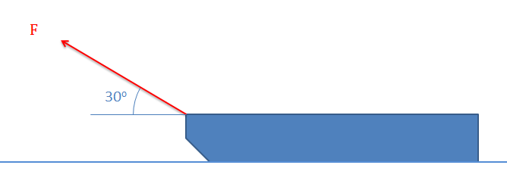

Solution: FPull = 3.28 lbs

Problem 7.2

A wooden box sits on a concrete slope (μs = .62, μk= .55). How strong of a force would be needed to start pulling this box up the ramp? If we let go of the box would it slide down the ramp?

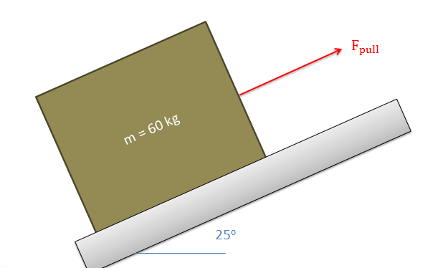

Solution: FPull = 578.9 N, Box will not slip if released

Problem 7.3

A wheelbarrow with a weight of 60 lbs sits on a ten-degree incline with the dimensions shown below. Assume friction exists at the rear support (A) but no friction exists at the wheel (B). What is the minimum coefficient of friction needed between the support and the ground to keep the wheelbarrow from sliding down the hill?

Solution: µs = .418

Problem 7.4

The car below weighs a total of 1500 lbs, has the center of mass as shown, and is rear wheel drive (only the rear wheels will create a friction force). Assuming that the tires are rubber and the surface is concrete (μs = .9), what is the maximum angle of the hill (Θ) that the car will be able to climb at a constant rate before the wheels start to slip? What is the maximum angle if the car is front wheel drive?

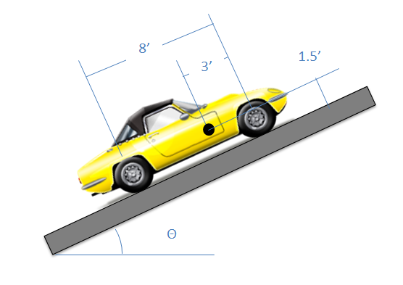

Solution: θMax = 22.0o for rear wheel drive, θMax = 25.7o for front wheel drive,

Problem 7.5

The fridge shown below has a total weight of 120 lbs and a center of mass as shown below. The fridge is pushed as shown until it either starts to slide or tips over. What is the minimum coefficient of friction needed to have the fridge tip before it starts sliding.

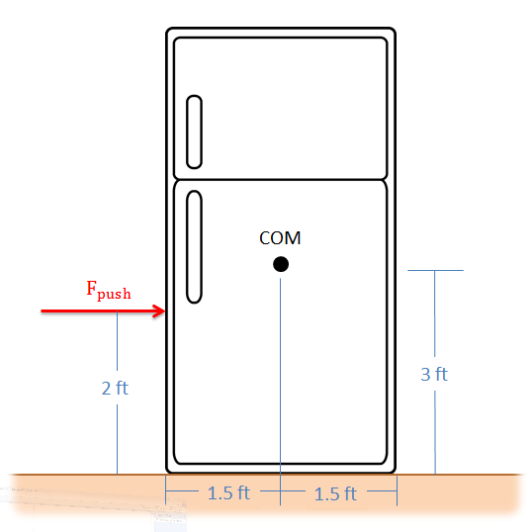

Solution: µs = .75 at a minimum

Problem 7.6

You have a bookshelf with the dimensions and weight shown below. You are examining the safety of your design.

* If a toddler were to pull as shown, what is the pulling force that would tip over the bookshelf? (assume the center of gravity is the center of the bookcase and no slipping)
* What would the static coefficient of friction need to be to have the shelf slide before it tips over?

Solution: Fpull = 34.64 lbs, µs = .218 at a maximum

Problem 7.7

The wedge shown below is pressed by a log splitter into a log with a force of 200 lbs. Assuming the coefficient of friction (both static and kinetic) between the steel wedge and the wood of the log is .3, what is the magnitude of the normal force exerted on either side of the log?

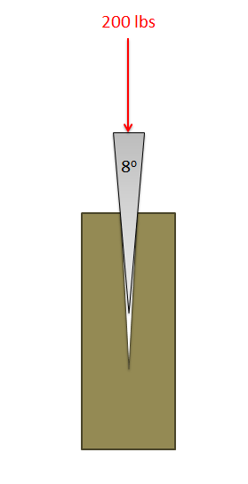

Solution: FN1 = FN2 = 271.0 lbs

Problem 7.8

The power screw in the screw jack shown below has an outside diameter of one and a half inches and a total of three threads per inch. (Assume the coefficients of friction are both .16)

1. What is the moment required to create a two ton (4000 lbs) lifting force?
2. Is this power screw setup a self-locking?

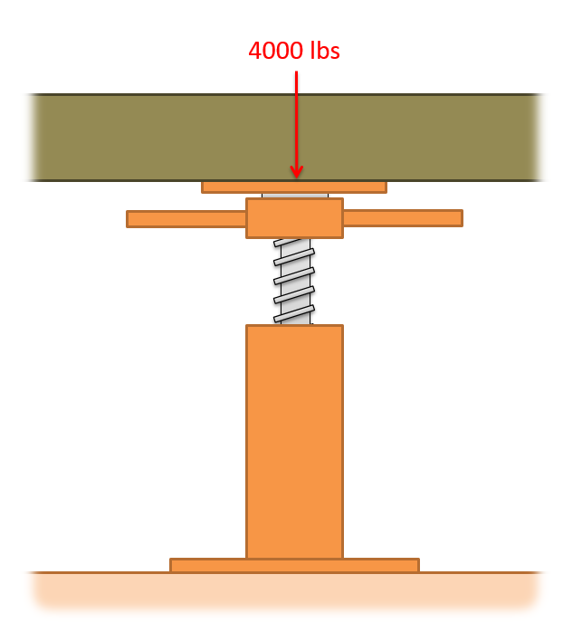

Solution: Mlift = 58.3 ft lbs, screw is self-locking

Problem 7.9

The end bearing as shown below is used to support a rotating shaft with a 300 N load on it. If the shaft and the bearing surface are both lubricated steel (Assume the coefficients of friction are both .06), what is the moment exerted by the friction forces for a…

1. A solid shaft with a diameter of 2cm
2. A hollow shaft with an outside diameter of 2cm and an inside diameter of 1.5 cm

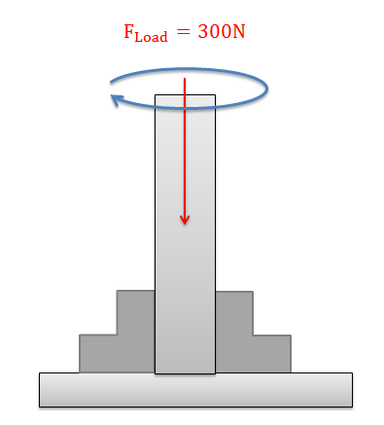

Solution: Mfriction = .12 Nm (solid shaft) Mfriction = .159 Nm (hollow shaft)

Problem 7.10

A 120 lb person is being lifted by a rope thrown over a tree branch as shown below. If the static coefficient of friction between the rope and the tree branch is .61, what is the pulling force required to start lifting the person? What is the pulling force required to keep them from falling?

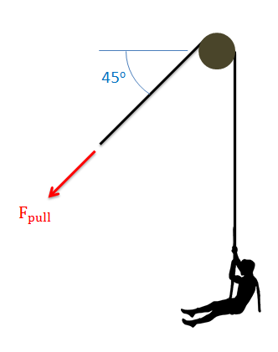

Solution: Flift = 505.1 lbs, Fstay = 28.5 lbs